Expressopay Update (2.2.3) or later

A new version of Expressopay is available. There are important updates described briefly following these update instructions.

Instructions to complete the update are as follows:
Please note that all computers that have Expressopay installed must be updated to the current version.
If you or your technical staff require assistance, please call R&L at 908.479.1995
- Please make sure Expressopay is closed before beginning the update
- Follow the link to ExpayUpdate
(Application) https://www.mypayrollreports.com/downloads/#expressopay_downloads
- Begin the application to installation by answering Run within your internet browser
Allow the installer through any antivirus or firewall applications
- Answer OK to Extract message
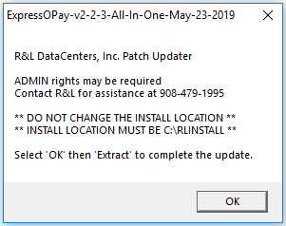

- Click Extract
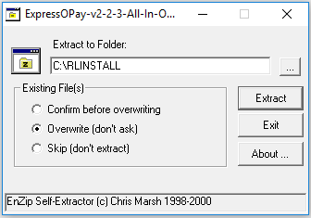

- Answer OK to finish message after all files have been extracted
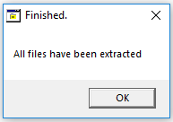

- Open Expressopay to confirm that you are operating the most current version (v2.2.3 [or later] will be indicated above the menu line; before your client number and name)
- Repeat the process for all computers that have Expressopay installed

Items Addressed
- GTL/DCRP Ineligibility /Added Employee Master field (Additional Employee Info Tab):
Group Term Life / Defined Contribution Retirement Program Ineligibility check box should be indicated for any employee who is participating in DCRP but is not eligible for the employer paid GTL benefit
- Social Security Number update fixed
- Summer Pay: Additional special summer pay options have been opened for months June through September for school clients
- Dues / Exclusion During Summer Months: In the same manner as D13 Dues, all dues deductions indicated as NJEA will be excluded automatically at Date Record
- Report Printing: Fix to report printing defaulting to “No Printer”
- Dotnet (for future use)
- Summer Pay 10-Month Contract Message: Fix to Date Record message “10-Month Contracts being paid” if Exclude 10 Month Summer Pay option selected

